TPM Pooled Fund Peer Exchange TPM Implementation
Sponsored by the TPM Pooled Fund

Dates: Thursday, November 14, 2019 Noon – 5:45 PM
Friday, Nov, 15, 2019 8:00 AM – Noon

Location: Room B27/B40, MnDOT Central Office TEC Center, 395 John Ireland Boulevard, St. Paul, MN 55155

Contents
Introduction to the Peer Exchange……………………...2
Peer Exchange Agenda…………………………………4
Peer Exchange Attendees………………………………7
Setting the Context: TPM Implementation Scope……..9

TPM Pooled Fund Peer Exchange
TPM Implementation

The 2019 Transportation Performance Management (TPM) Pooled Fund Peer Exchange will focus on how transportation agencies are implementing TPM in their agencies in light of federal requirements and to advance TPM and performance-based planning and programming (PBPP) practice. The purpose of the peer exchange is to provide participants an opportunity to share their experiences implementing TPM and to discuss related best practices.

Background and Context

While federal requirements related to performance management are less than 10 years old, agencies have been practicing and implementing transportation performance management for decades as a way to maximize the life and effectiveness of their transportation system, enhance safety and demonstrate wise stewardship of transportation funds.

Federal Transportation Performance Management (TPM), performance-based planning and programming (PBPP) and other related provisions that apply to State Departments of Transportation (State DOTs), Metropolitan Planning Organizations (MPOs) and transit agencies were initiated in the Moving Ahead for Progress in the 21st Century Act (MAP-21) and reaffirmed in Fixing America's Surface Transportation Act (FAST Act). These requirements have established a national focus for transportation as “a strategic approach that uses system information to make investment and policy decisions to achieve national performance goals.”

The first performance period for TPM began on January 1, 2018, and will end on December 31, 2021 with the exception of the CMAQ emissions measure, which = began on October 1, 2017, and will end on September 30, 2021.
States are also required to meet biennial reporting requirements related to targets and progress. The baseline report for the first performance period was due October 1, 2018, for all measures under this final rule.

Targets are quantitative performance goals expressed as a value for a measure, to be achieved within a timeline. State DOTs were required to set their targets for infrastructure condition (PM2) and system performance (PM3) by May 20, 2018. The target reporting deadline for all measures in the PM2 and PM3 rules for the first performance period was October 1, 2018. Four-year targets may be adjusted at the mid-point of a Performance Period. 2-year targets may not be adjusted. State DOTs are required to coordinate with MPOs to ensure consistency to the maximum extent practicable.

States and MPOs were required to establish performance-based planning requirements two years from the effective date of each rule. State DOTs’ and MPOs’ amended or updated TIPs/STIPs must meet federal PBPP planning requirements, and LRSTP/MTP must also be developed using the performance-based planning requirements including performance measures, targets and a report on system performance.

Peer Exchange Overview

This peer exchange will provide a forum for agencies to share and discuss TPM and PBPP implementation practices, including how to resource and align their internal performance management systems with federal requirements. They will discuss current communication challenges and the future of TPM. The primary goal of this peer exchange is to advance the state of the TPM practice, particularly by sharing lessons learned.

Participants will also learn about resources that are available to support TPM implementation.

Agencies will share how they are managing short and long term system performance and how they are balancing investment decisions. How agencies are setting targets and managing targets in the context of performance-based planning, budgeting and management will be a focus.

As part of the workshop, the participating agencies will prioritize TPM implementation initiatives. supporting entities such as FHWA, AASHTO, AMPO, and TRB.

The peer exchange is organized around the
following core activities:

- Share the experience of recent TPM implementation, including the best examples of how the TPM has led to advancement in the organization and with partner organizations
- Discuss the ingredients for good TPM implementation
- Develop a vision of what the next generation of TPM will look like
- Prioritize initiatives for future TPM activities for FHWA, AASHTO, AMPO, and TRB to undertake

TPM Pooled Fund Peer Exchange Agenda
Sponsored by the AASHTO TPM Pooled Fund
Dates: Thursday, November 14, 2019 12:00 PM – 5:45 PM
Friday, November 15, 2019 8:00 AM – Noon
Location: MnDOT Central Office TEC Center, 395 John Ireland Boulevard, St. Paul, MN 55155

Members of the AASHTO TPM Pooled Fund will gather at a peer exchange to focus on how transportation agencies are implementing TPM in their agencies in light of federal requirements and to advance TPM practice. Agencies will share how they are managing short and long term system performance and how they are balancing investment decisions. How agencies are setting targets and managing targets in the context of performance-based planning, budgeting, and management will be a focus. The participants will be engaged in a process to prioritize TPM advancement topics for future national research and implementation will be a part of the peer exchange.
Peer Exchange Purpose:
- Advance the state of the TPM practice, including lessons learned
- Discuss the ingredients for good TPM implementation
- Gain knowledge of the resources that are available to support TPM implementation
- Share the experience of recent TPM implementation, including the best examples of how the TPM has led to improved system performance in the organization and with partner organizations
- Discuss what the next generation TPM will look like at state DOTs and MPOs
- Prioritize future TPM initiatives for FHWA, AASHTO, and TRB

A G E N D A
Day 1 – Thursday, November 14, 2019
Introductions

Noon – 1:00 pm Lunch available for participants

1:00 - 1:30 pm Welcome, Opening Remarks
Tim Henkel, Minnesota DOT, Susanna Reck, FHWA,
Christos Xenophontos, Chair, TPM Pooled Fund

TPM Pooled Fund Accomplishments
Matt Hardy, AASHTO

Peer Exchange Overview and Objectives
Hyun-A Park, Spy Pond Partners, LLC

A. PBPP – Resource Allocation
Implementing performance based planning and programming (PBPP) is a key challenge facing many transportation agencies. Linking planning and programming to good investment decision-making yields good performance results. This session looks at examples of resource allocation practice and will end with a group discussion on how to improve investment decision-making.
1:30 – 2:00 - Matt Haubrich, Iowa DOT – Data-Driven Project Initiation and Prioritization
- Karen Miller, Missouri – Resourcing TPM and PBPP
- Ryan Granger, Texas DOT – Maximizing Efficiency Through Predictive Tools

2:00 - 2:45 Large Group Discussion
B. PBPP – Federal Measures and Requirements
This session continues the focus on PBPP. Many agencies identified the challenges of aligning federal measures and requirements with their agency’s TPM practices. This session will start with agencies sharing their challenges with integrating federal measures and requirements and end with small group breakouts to generate ideas for how to make improvements at both the federal and state levels.
2:45 – 3:05 - Edgardo Block, Connecticut DOT – Reconciliation of State & National Measure Dashboards
- Deanna Belden Minnesota DOT – Integrating Federal Measures into a Mature Performance Management System
3:05 - 3:20 Break

3:20 - 4:15 Small Group Discussion
4:15 – 4:45 Group Reports

C. Emerging Agency Needs
Agencies that are just starting their TPM implementation process will share their challenges (5 minute shares) and pose the needs they have in implementing TPM.
4:45 – 4:50 - Rachel Roper, Hawaii DOT

4:55 - 5:30 Large Group Discussion

Peer exchange participants will be asked to develop ideas for how emerging agencies can accelerate their TPM progress.
Day 1 Wrap Up
5:30 – 5:45 Summary of Day 1 Discussion, Ideas to Consider, Overview of Thursday’s Agenda
Karen Miller, Missouri DOT

Day 2 – Friday, November 15, 2019
Day 2 Introduction
8:00 - 8:30 Recap Thursday’s Agenda and Overview of Friday’s Agenda Edgardo Block, Connecticut DOT
Hyun-A Park, Spy Pond Partners, LLC
D. TPM Communication Challenges
Good TPM communication is a challenge that is facing DOTs as both federal and their agency TPM programs are maturing and performance results are available to the public. This session will start with agencies sharing noteworthy practices on communicating TPM and end with a group discussion on what is needed nationally and how to support different levels of communication maturity across agencies.
8:30 - 9:00 - Holly Bieneman, Illinois DOT – Collaborating and Coordinating with MPOs and Transit Agencies on PBPP Activities
- Gabe Philips, Washington State DOT – Communicating and Reporting Project Performance
- Chris Berrens, Minnesota DOT – The Evolution of Reporting and Communicating Results

9:00 - 10:00 Large Group Discussion
10:00 - 10:15 Break

E. Speed Sharing – TPM Lessons Learned
The following peer exchange participants will share their TPM lessons learned through 5-minute highlights that are supported by documentation that will be available to all participants before the peer exchange. The purpose of this session is to share the wisdom gained through both TPM successes and failures.
10:15 - 10:55 - Jackie Irving, Wisconsin DOT
- Thor Anderson, Arizona DOT
- Steve Guenther, California DOT
- Rick Johnson, Oklahoma DOT
- Kelly Travelbee, Michigan DOT
- Pat Cowley, Utah DOT
- Gehan Elsayed, West Virginia DOT
- Toria Lassiter, Maryland Department of Transportation State Highway Administration

10:55 - 11:30 Large Group Discussion
Priority Needs and Peer Exchange Wrap-Up
11:30 – Noon Discussion of Priority Issues and Future Activities, Summary of Peer Exchange
Christos Xenophontos, Chair, TPM Pooled Fund

Peer Exchange Attendees
Arizona Department of Transportation
Thor Anderson
tanderson@azdot.gov

Arizona Department of Transportation
Greg Byers
Gbyers@azdot.gov

California Department of Transportation
Steve Guenther
steve.guenther@dot.ca.gov

Connecticut Department of Transportation
Edgardo Block
Edgardo.Block@ct.gov

Connecticut Department of Transportation
Michael Cohen
Michael.Cohen@ct.gov

Connecticut Department of Transportation
Alexander Finch
Alexander.Finch@ct.gov

Delaware Department of Transportation
Maureen Kelley
Maureen.Kelley@delaware.gov

Hawaii Department of Transportation
Rachel Roper
Rachel.LA.Roper@hawaii.gov

Iowa Department of Transportation
Matthew Haubrich Matthew.Haubrich@iowadot.us

Iowa Department of Transportation
Charlie Purcell
Charlie.Purcell@iowadot.us

Illinois Department of Transportation
Holly Bieneman
Holly.Bieneman@illinois.gov

Illinois Department of Transportation
Bill Morgan
William.Morgan@illinois.gov

Maryland State Highway Administration
Toria Lassiter
TLassiter@mdot.maryland.gov

Michigan Department of Transportation
Kelly Travelbee
TravelBeeK@michigan.gov

Minnesota Department of Transportation
Tim Henkel
tim.henkel@state.mn.us

Minnesota Department of Transportation
Tim Henkel
tim.henkel@state.mn.us

Minnesota Department of Transportation
Deanna Belden
deanna.belden@state.mn.us

Minnesota Department of Transportation
Jean Wallace
jean.wallace@state.mn.us

Minnesota Department of Transportation
Michael Iacono
michael.iacono@state.mn.us

Minnesota Department of Transportation
Chris Berrens
chris.berrens@state.mn.us

Missouri Department of Transportation
Karen Miller
Karen.Miller@modot.mo.gov

New York State Department of Transportation
Alan Warde
Alan.Warde@dot.ny.gov

New Mexico Department of Transportation
Tammy Haas
TamaraP.Haas@state.nm.us

Oklahoma Department of Transportation
Rick Johnson
RJOHNSON@ODOT.ORG

Tennessee Department of Transportation
Michelle Nickerson
Michelle.Nickerson@tn.gov

Texas Department of Transportation
Peggy Thurin
Peggy.Thurin@txdot.gov

Texas Department of Transportation
Ryan Granger
Ryan.Granger@txdot.gov

Utah Department of Transportation
Patrick Cowley
patrickcowley@utah.gov

Washington State Department of Transportation
Gabe Philips
PhilipG@wsdot.wa.gov

West Virginia Department of Transportation
Gehan Elsayed
Gehan.M.Elsayed@wv.gov

Wisconsin Department of Transportation
Jackie Irving
JacquelynM.Irving@dot.wi.gov

American Association of State Highway and Transportation Officials (AASHTO)
Matt Hardy
mhardy@aashto.org

Federal Highway Administration (FHWA)
Susanna Reck
susanna.reck@dot.gov

Ryan Hixson
ryan.hixson@dot.gov

TPM Pooled Fund
Chair, TPM Pooled Fund
Christos Xenophontos
christos.xenophontos@dot.ri.gov

Peer Exchange Staff
Spy Pond Partners, LLC
Hyun-A Park
hpark@spypondpartners.com

Lori Richter
lrichter@spypondpartners.com

Setting the Context:
Figure 1.
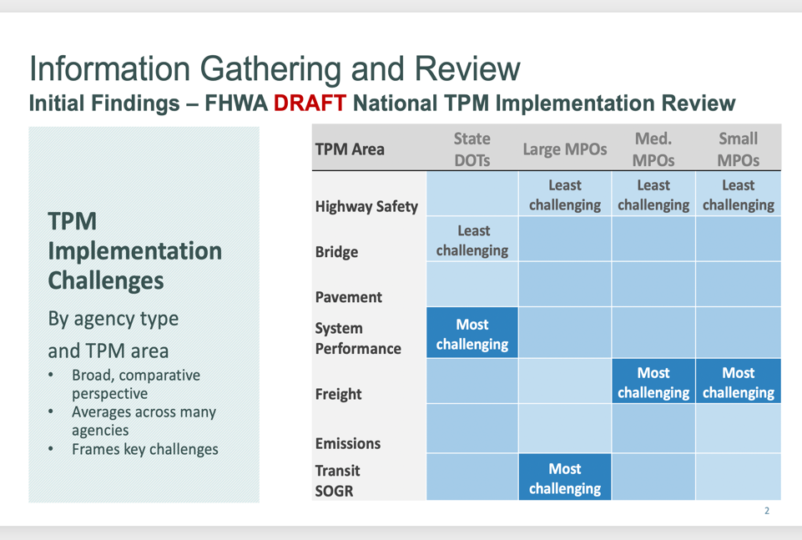

Summary

As shown in Figure 1., the FHWA National TPM Implementation Review (NIR) found that national bridge measures are the least challenging for state DOTs to implement, and system performance measures are the most challenging. The NIR looked at TPM implementation challenges by agency type and TPM area.

As shown in Figure 2., FHWA also tracked “basis of target” comments in PM1, PM2 and PM3 submittals; the most frequent issues by TPM area and TPM process were related to pavement/target setting.

Examples of TPM pavement/target setting issues are noted in Figure 3 below.
Figure 2.
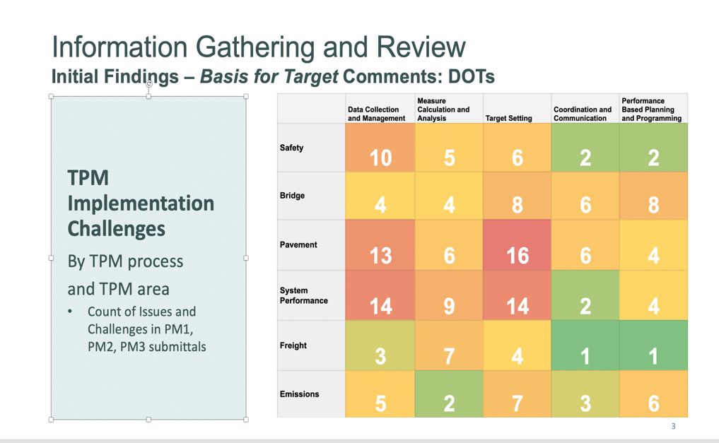
Figure 3.

